Run powershell as admin:

Download Minikube:

<https://minikube.sigs.k8s.io/docs/start/?arch=%2Fwindows%2Fx86-64%2Fstable%2F.exe+download>

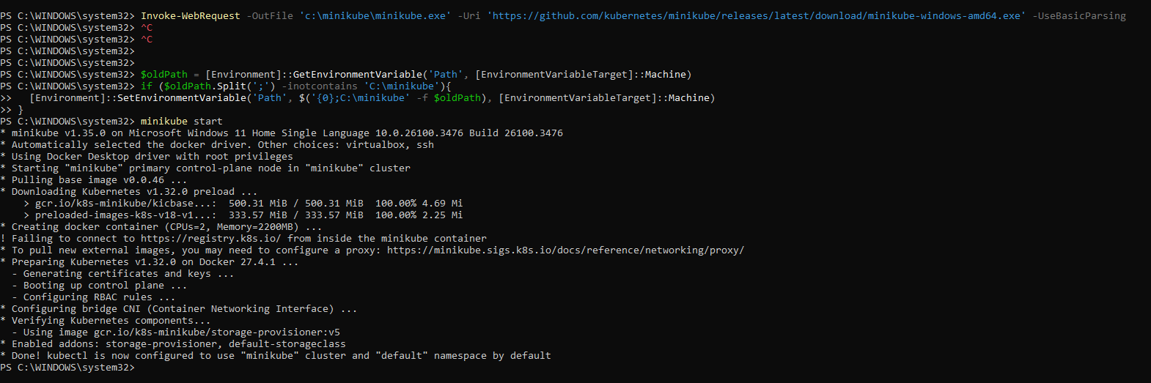

For Virtual box:

* minikube start --driver=virtualbox --no-vtx-check
* 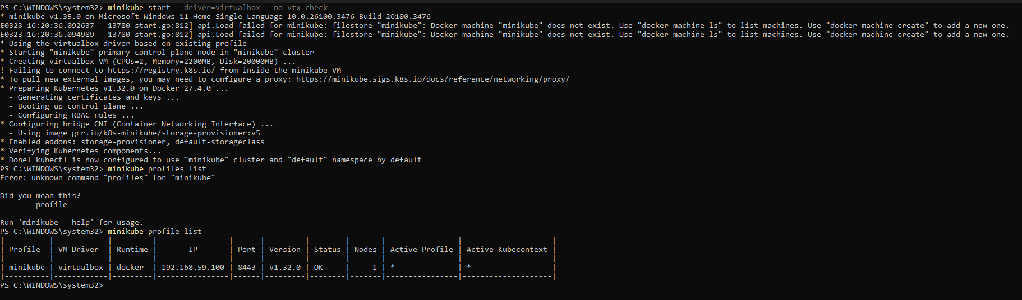
* 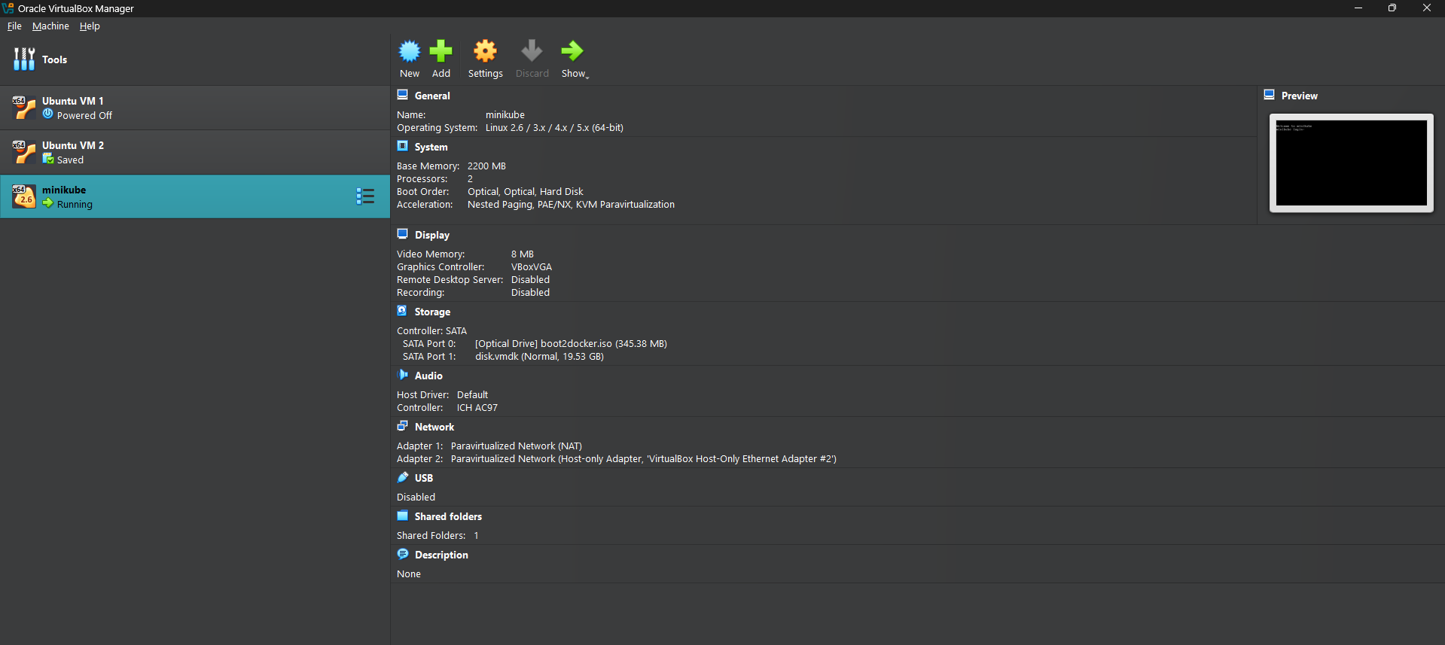

Install kubectl

<https://kubernetes.io/docs/tasks/tools/install-kubectl-windows/>

